Weekly report

1. **My *Goals* from last week**
   1. Present Paper
   2. Create a new lever arm
2. **My *Accomplishments* this week**
   1. Project 1: < Lever Arm Prototyping>
      1. Took suggestions from lab members on how to measure the force of the kilobots
      2. Create a wooden prototype that stops the kilobots from being able to turned
      3. Printed stand-offs and plugs to attach the arm together to form an arm longer than the laser cutter can print. 3D models pushed to github.
         1. <https://github.com/aabecker/LaserCutter3DPrinter/blob/master/3Dprinter/Lillian Lin/Feet.stl>
         2. <https://github.com/aabecker/LaserCutter3DPrinter/blob/master/3Dprinter/Lillian Lin/Plug.stl>
         3. <https://github.com/aabecker/LaserCutter3DPrinter/blob/master/3Dprinter/Lillian Lin/Screw Size Test.ipt>
      4. 1 prototype completed
   2. Project 2: < New Games >
      1. Created a visual representation of the mean and variance of both mean and variance that is unique to each object
      2. Created drawing code and physics code for a 4 piece puzzle and a 2 piece puzzle (picture seen below)
      3. Edited codes above to add tolerance
      4. Helped Shiva debug

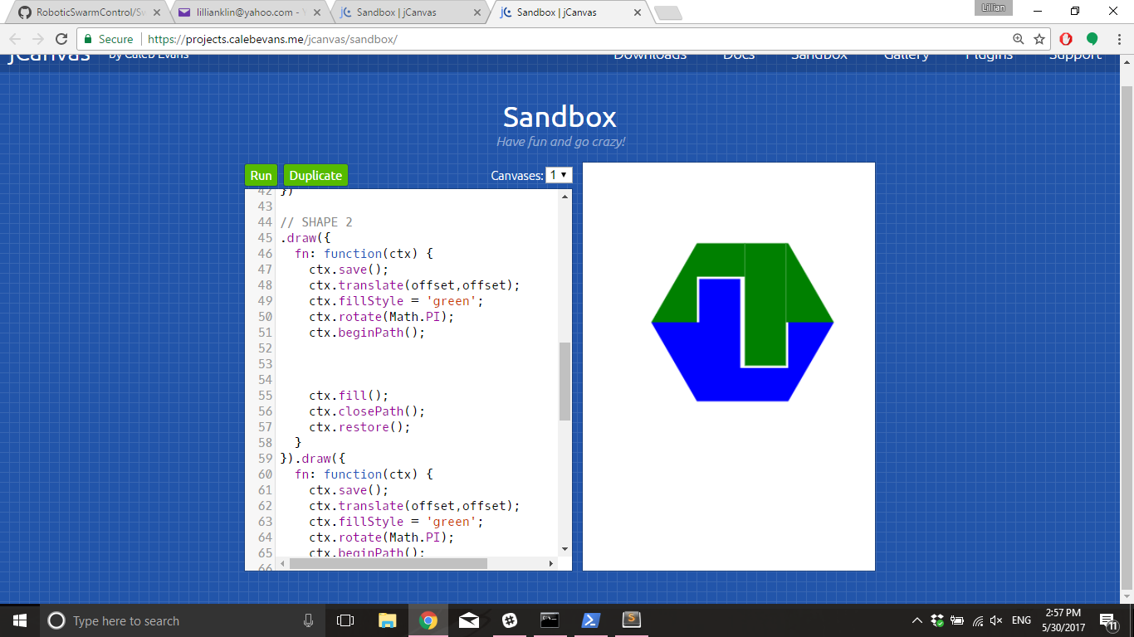

Figure 1 - Example of one of the shapes that were created for SwarmControl.net

* 1. Project 3: < Weekly Presentation >
     1. Read Paper and analyzed it for similarities to the kilobot research
     2. A copy of my powerpoint has been added

1. **My *Goals* for next week**
   1. (Let’s set the bar lower so I stop failing) Find a sensor that actually senses kilobots
   2. Assemble new lever arm
   3. Test new lever arm
2. **Needed from Dr Becker**
   1. Am I supposed to be doing something in particular to get paid, like clocking in or something?